**Practical-1**

**Aim: Write a C program to print all alphabets from a to z. using do-while loop.**

**Program:**

#include<stdio.h>

#include<conio.h>

main()

{

char ch;

clrscr();

ch='a';

do

{

printf(" %c ",ch);

ch++;

}

while(ch<='z');

getch();

}

**Output:**

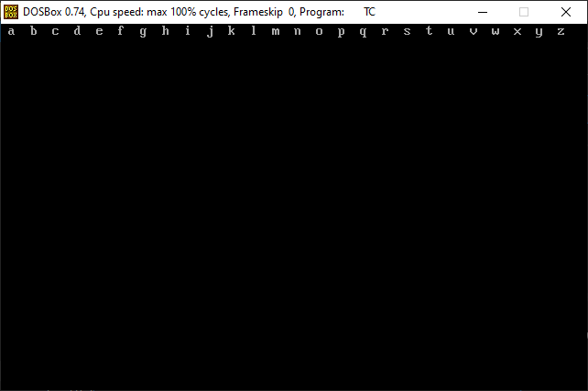

**Practical-2**

**Aim: Write a C program to count a number of digits in a number.**

**Program:**

#include<stdio.h>

#include<conio.h>

main()

{

int num,c=0;

clrscr();

printf("=> Enter any number :- ");

scanf("%d",&num);

while(num!=0)

{

num=num/10;

c++;

}

printf("=> The number of digits :- %d",c);

getch();

}

**Output:**

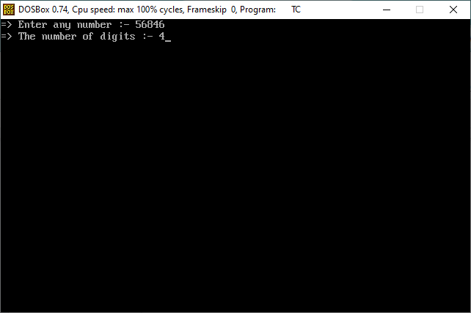

**Practical-3**

**Aim: Write a C program to find the sum of the first and last digit of a number.**

**Program:**

#include<stdio.h>

#include<conio.h>

main()

{

int num,f,l;

clrscr();

printf("=> Enter any number :- ");

scanf("%d",&num);

l=num%10;

while(num>10)

{

num=num/10;

}

f=num;

printf("=> The sum of first & last number :- %d",f+l);

getch();

}

**Output:**

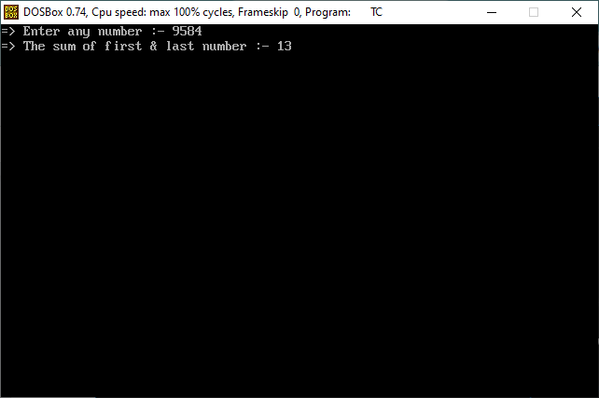

**Practical-4**

**Aim: Write a C program to enter a number and print its reverse & check whether num is palindrome or not?**

**Program:**

#include<stdio.h>

#include<conio.h>

main()

{

int num,rev=0,temp;

clrscr();

printf("=> Enter any number :- ");

scanf("%d",&num);

temp=num;

while(num>0)

{

rev=(rev*10)+num%10;

num=num/10;

}

printf("\n=> Convert into reverse number :- %d",rev);

if(temp==rev)

{

printf("\n\n=> This number is palindrome number.");

}

else

{

printf("\n\n=> This number is not palindrome number.");

}

getch();

}

**Output:**

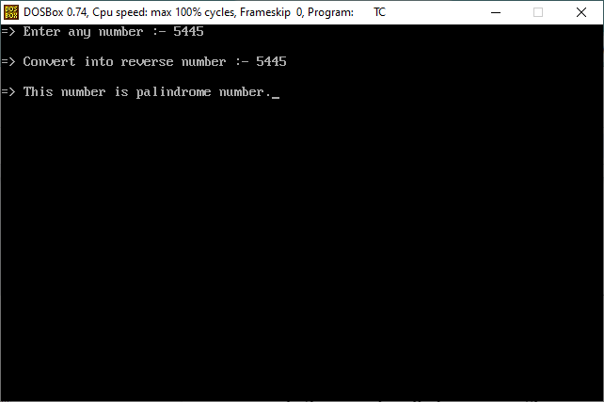

**Practical-5**

**Aim: Write a C program print out Fibonacci series. (0,1,1,2,3,5,8…).**

**Program:**

#include<stdio.h>

#include<conio.h>

main()

{

int a=0,b=1,c,x,num;

clrscr();

printf("=> Enter any number :- ");

scanf("%d",&num);

printf("\n %d %d",a,b);

for(x=2;x<num;++x)

{

c=a+b;

printf(" %d",c);

a=b;

b=c;

}

getch();

}

**Output:**

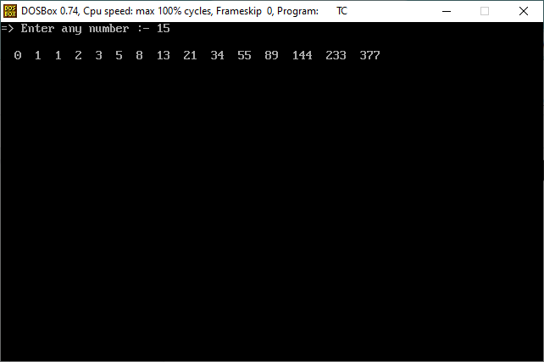

**Practical-6**

**Aim: Write a C program check whether num is prime or not.**

**Program:**

#include<stdio.h>

#include<conio.h>

main()

{

int num,a,b=0;

clrscr();

printf("=> Enter any number :- ");

scanf("%d",&num);

for(a=1;a<=num;a++)

{

if(num%a==0)

{

b++;

}

}

if(b==2)

{

printf("\n=> This number is prime number.");

}

else

{

printf("\n=> This number is not prime number.");

}

getch();

}

**Output:**

